LAB ASSIGNMENT NO: 07

**(Continued from Lab Assignbment-4)**

create table department

(

DeptNumber number primary key

);

create table emp

(

EmpNo number primary key,

EName varchar(100) unique,

Job varchar(100),

Salary number not null,

DeptNo number,

check(Job in ('Prof','AP','Lect')),

foreign key(DeptNo) references department(DeptNumber)

);

create table J

(

JNo number primary key,

JName varchar(100),

City varchar(100)

);

**Q1) Check the structure of tables.**

desc department;

desc emp;

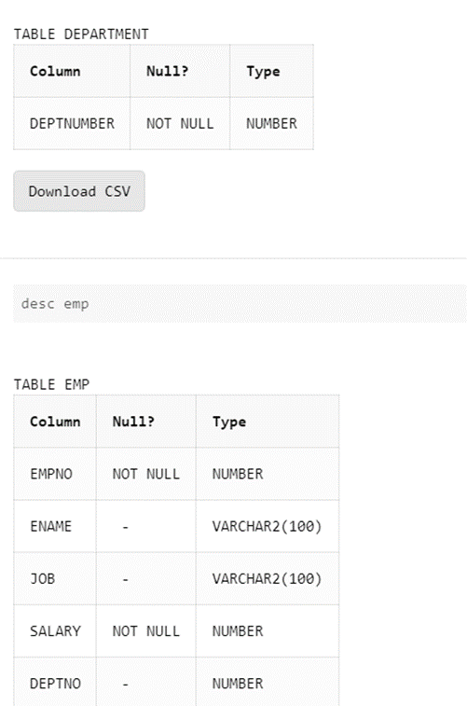

**Q2) Check the constraint name for applied constraints?**

SELECT constraint_name FROM all_constraints WHERE table_name = 'emp';

**Q3) Drop the unique constraint on ENAME**

ALTER TABLE emp DROP CONSTRAINT SYS_C00115220908;

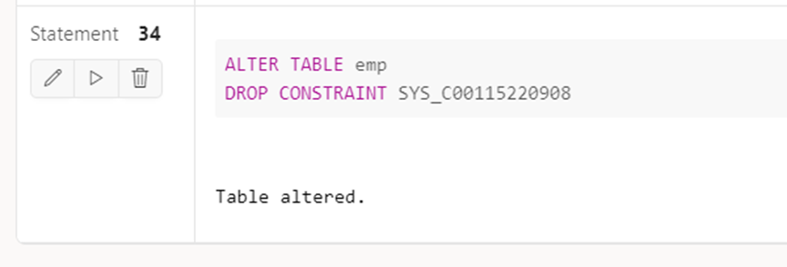

**Q4) Drop the Foreign Key constraint on DEPTNO**

ALTER TABLE emp DROP CONSTRAINT SYS_C00115220909;

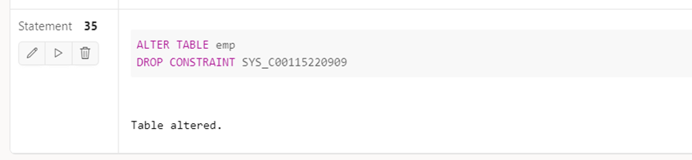

**Q5) Add Foreign Key constraint on DEPTNO**

alter table emp add foreign key (DeptNo) references department(DeptNumber);

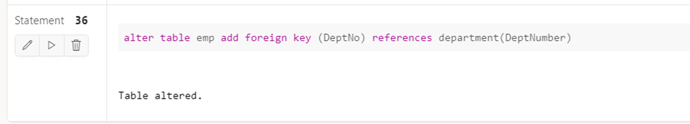

**Q6) Change Data type of ENAME**

alter table emp modify EName char(100);

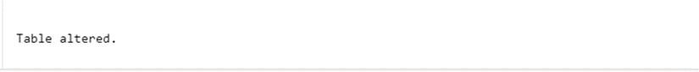

**Q7) Change width of ENAME**

alter table emp modify EName char(50);



**Q8) Add COMM column in EMP table**

alter table emp add Comm varchar(50);

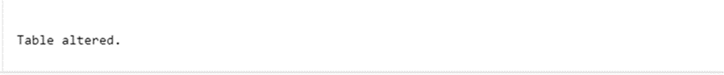

**Q9) Drop CITY column from J table**

alter table J drop column City;



**Q10) Create duplicate copy of EMP table**

CREATE TABLE emp_new AS SELECT * FROM emp;

desc emp_new;

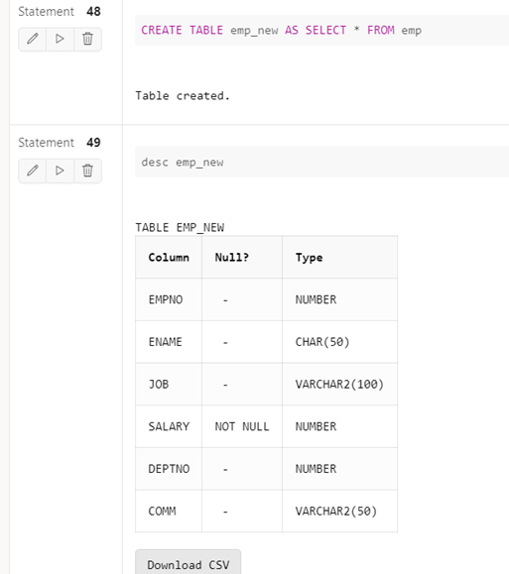

**Q11) Copy structure of DEPT table in another table with**

**different column names**

CREATE TABLE dept(DeptNo number);

select DeptNumber as DeptNo into dept from department where 1=0;

**Q12) Change the name and job of the employee whose EMPNO =100**

update emp set EName = 'A', Job = 'AP' where EmpNo = 100;

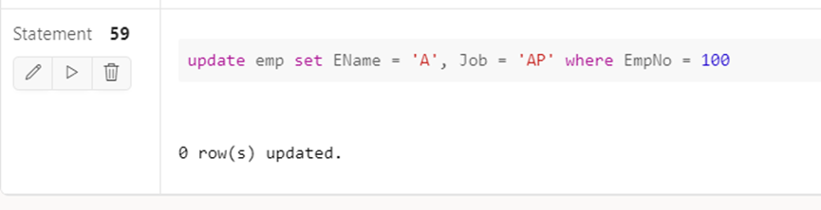

**Q13) Delete the record of employee who belongs to computer**

**department**

delete from emp where Job = 'Computers';

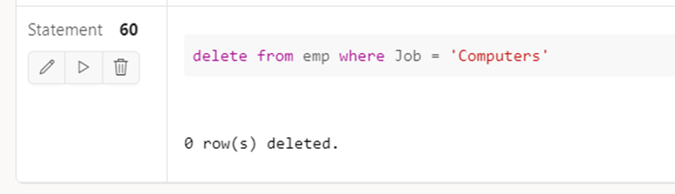

**Q14) Drop DEPT Table**

drop table dept;

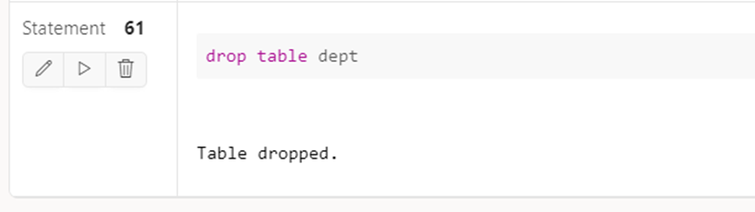

**Q15) Drop duplicate table of EMP table**

drop table emp_new;

